**Activity Monitoring and Unusual Activity Detection for Elderly Homes**

1. **Problem Statement**

The objective of this project is to monitor and detect unusual activity for an elderly person [1]. Individuals spend the majority of their time in their home or workplace and many feels that these places are their sanctuaries. The sensors collect information about the state of the home and resident [2]. Activity learning techniques use this information to identify and reason about routine or normal behavior in terms of recognized and forecasted activities. This identified behavior forms the basis for threat detection based on sensing abnormal behavior. Once the abnormal behavior is identified as a threat, the home selects an action to take as a response. We evaluate our approach in the context of actual smart home test beds. The elderly may require frequent, immediate medical intervention, which may otherwise result into fatal consequences [1]. Such emergency situations can be avoided by monitoring the physiological parameters and activities of the elderly in a continuous fashion. In most emergency cases, the elderly seek in-patient care, which is very expensive and can be a serious financial burden on the patient if the hospital stay is prolonged. The proposed work allows people to remain in their comfortable home environment rather than inexpensive and limited nursing homes or hospitals, ensuring maximum independence to the occupants. Therefore, an affordable, un-obtrusive and comprehensive healthcare solution with minimal workforce is of utmost importance for long-term health management and monitoring, especially for the rapidly rising elderly population.

1. **Background**

Recently, there has been an elderly person activity detection or Human activity recognition (HAR) [1,3] work via Deep Belief Network (DBN) [4] which is one of Deep Neural Networks (DNNs) proposed by Hilton in 2009. DBN uses Restricted Boltzmann Machines (RBMs) in learning and it avoids local minimum problem with less training time. However, Recurrent Neural Networks (RNNs) is a better choice than DBN, since it could offer more discriminative power over DBN as time sequential information can be encoded or learned through RNNs. Although HMM [3] can handle time sequential information, now researchers prefer RNN over HMM for its improved discriminant capability. There are challenges in activity recognition that are unique among machine learning problems. The input data is often sequential and noisy, the data is not clearly partitioned into activity segments, and the data is occasionally multi-label. The approach to threat detection in smart homes is unique because it incorporates knowledge of current and activities to determine deviations from normal behavioral patterns. Those deviations represent potential threats that require further investigation and response. Most cyber-physical systems generally use a fixed set of parameters such as time and location to identify a current context, and this context forms the basis for many context-aware services including security services. In the area of identifying and assessing threats, many researchers take an approach similar to the one we propose by looking for outliers in sensor data patterns and viewing such outliers as threats to well-being. Unlike our approach, these previous methods do not look at activities and the related patterns. However, existing approaches have looked for outliers based on overall movement in the home, resident locations in a home, sensor event times, or sensor values. Deep learning refers to neural networks that exploit layers of non-linear data processing for feature classification. These layers are hierarchically organized and process the outputs of the previous layers. Deep learning techniques have outperformed many traditional methods in computer vision. The system may also include predictive algorithms in future, which will allow it to make predictive decisions about diseases at their early onset by analyzing the monitored data. If a potential health problem is predicted, the system can notify the corresponding healthcare personnel immediately over a secured communication channel for a detailed investigation. This may enable the individual to receive early diagnosis and prevent treatment delay.

1. **Methodology**

The prediction algorithms can exploit the features of artificial intelligence (AI) and make use of deep learning and machine learning techniques. In this paper, we present an RNN-based HAR system [5]. We have performed HAR with the features of body joint angles. The performance of RNN for HAR has been compared to other conventional recognizers such as HMM (Hidden Markov Model) and DBN. Undermentioned are the methodology steps:

Architecture of the human activity detection is depicted in Figure 1.

**Step 1: Data collection and creation of feature matrix**

First, we collect the dataset related to human activity from the repository as discussed in experimental design section. After then creation of feature matrix of joint angles computed from the MSRC-12 activity dataset.

**Step 2: Developing RNN based human activity detection model**

Train RNN with the training feature matrix. As a solution to vanishing gradient problem, LSTM (Long Short-term Memory) is used. Our RNN is trained with the training feature data via an extended backpropagation algorithm called Backpropagation Through Time.

**Step 3: Evaluation of RNN model**

Then evaluate the trained RNN with test data sets by recognizing twelve human activities. The recognition performance is compared to the results from the conventional HMM- and DBN-based HAR systems.

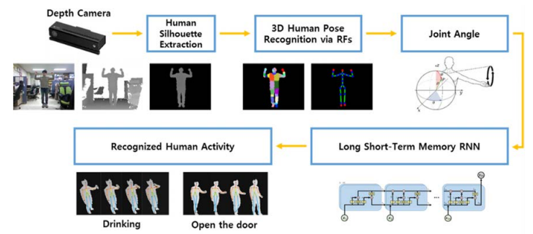

Figure 1: Deep learning model for human activity detection [6].

**Step 4: Deployment of project in real life scenario**

The trained and tested Human activity detection model will be deployed in real life for further analysis. The positive and negative response may be collected for improving the model and methodology.

1. **Experimental Design**
2. **Dataset**

Microsoft Research Cambridge-12 (MSRC-12) [7]. This dataset consists of sequences of human activities containing 12 activities: namely lift arms, duck, push right, goggles, wind it up, shoot, bow, throw, had enough, change weapon, beat both and kick respectively. The dataset includes the human skeletal joint positions at each frame, other information about the dataset as follows:

Number of sequences: 594

Number of frames: 719359

Time duration of video: 6 Hr. 40 Minutes

Sample collected from 30 people

Number of gesture: 12

Number of gesture instances: 6244

For the experimental setup or result comparison purpose may use dataset prepared by UCI [8].

1. **Evaluation Measures**

To evaluate our HAR system, we have compared the accuracy of HAR based on Hidden Markov Model, DBN and RNN respectively using the same MSRC-12 dataset.

1. **Software & Hardware Requirements**

Python based Computer Vision and Deep Learning libraries will be exploited for the development and experimentation of the project. Tools such as Anaconda Python, and libraries such as Tensorflow, and Keras will be utilized for this process.

1. **References**
2. Kim, Eunju, Sumi Helal, and Diane Cook. "Human activity recognition and pattern discovery." *IEEE Pervasive Computing*9.1 (2010).
3. Nam, S. B., et al. "Accurate 3D human pose recognition via fusion of depth and motion sensors." *International Journal of Future Computer and Communication* 4.5 (2015): 336.
4. Piyathilaka, Lasitha, and Sarath Kodagoda. "Gaussian mixture based HMM for human daily activity recognition using 3D skeleton features." *Industrial Electronics and Applications (ICIEA), 2013 8th IEEE Conference on*. IEEE, 2013.
5. Szegedy, Christian, et al. "Going deeper with convolutions." Cvpr, 2015.
6. Park, S. U., et al. "A depth camera-based human activity recognition via deep learning recurrent neural network for health and social care services." *Procedia Computer Science*100 (2016): 78-84.
7. Aalbersberg, IJsbrand, et al. "Bringing Digital Science Deep Inside the Scientific Article: the Elsevier Article of the Future Project." *Liber Quarterly* 23.4 (2014).
8. <https://www.microsoft.com/en-us/download/details.aspx?id=52283>
9. https://archive.ics.uci.edu/ml/datasets/human+activity+recognition+using+smartphones